Ex. No. : 04 Name: Shreya Amudhu.N.R

Register No. : 2116240701505

Report

Aim:
To create simple reports in Zoho Creator for a Library Management System without using Zia, using the existing forms and data for Loan Record, Library Items, Borrower, and Library Events.

Procedure:
- Open the Zoho Creator application containing the Library Management System.
- Open the application in Edit mode.
- Select the Reports section.
- Click Create Report and choose the required form as the data source.
- Create a any Report for the Loan Record form to display loan details such as borrower, library item, loan date, and return date.
- Create a any Report for the Library Items form to display item details such as item name, type, author, and availability.
- Create a any Report for the Borrower form to display borrower details such as name, contact information, and borrower ID.
- Create a any Report for the Library Events form to display event details such as event name, date, location, and description.
- Select the required fields for each report and arrange them in a simple tabular format.
- Save and open each report to verify that the existing records are displayed correctly.

Screenshots:
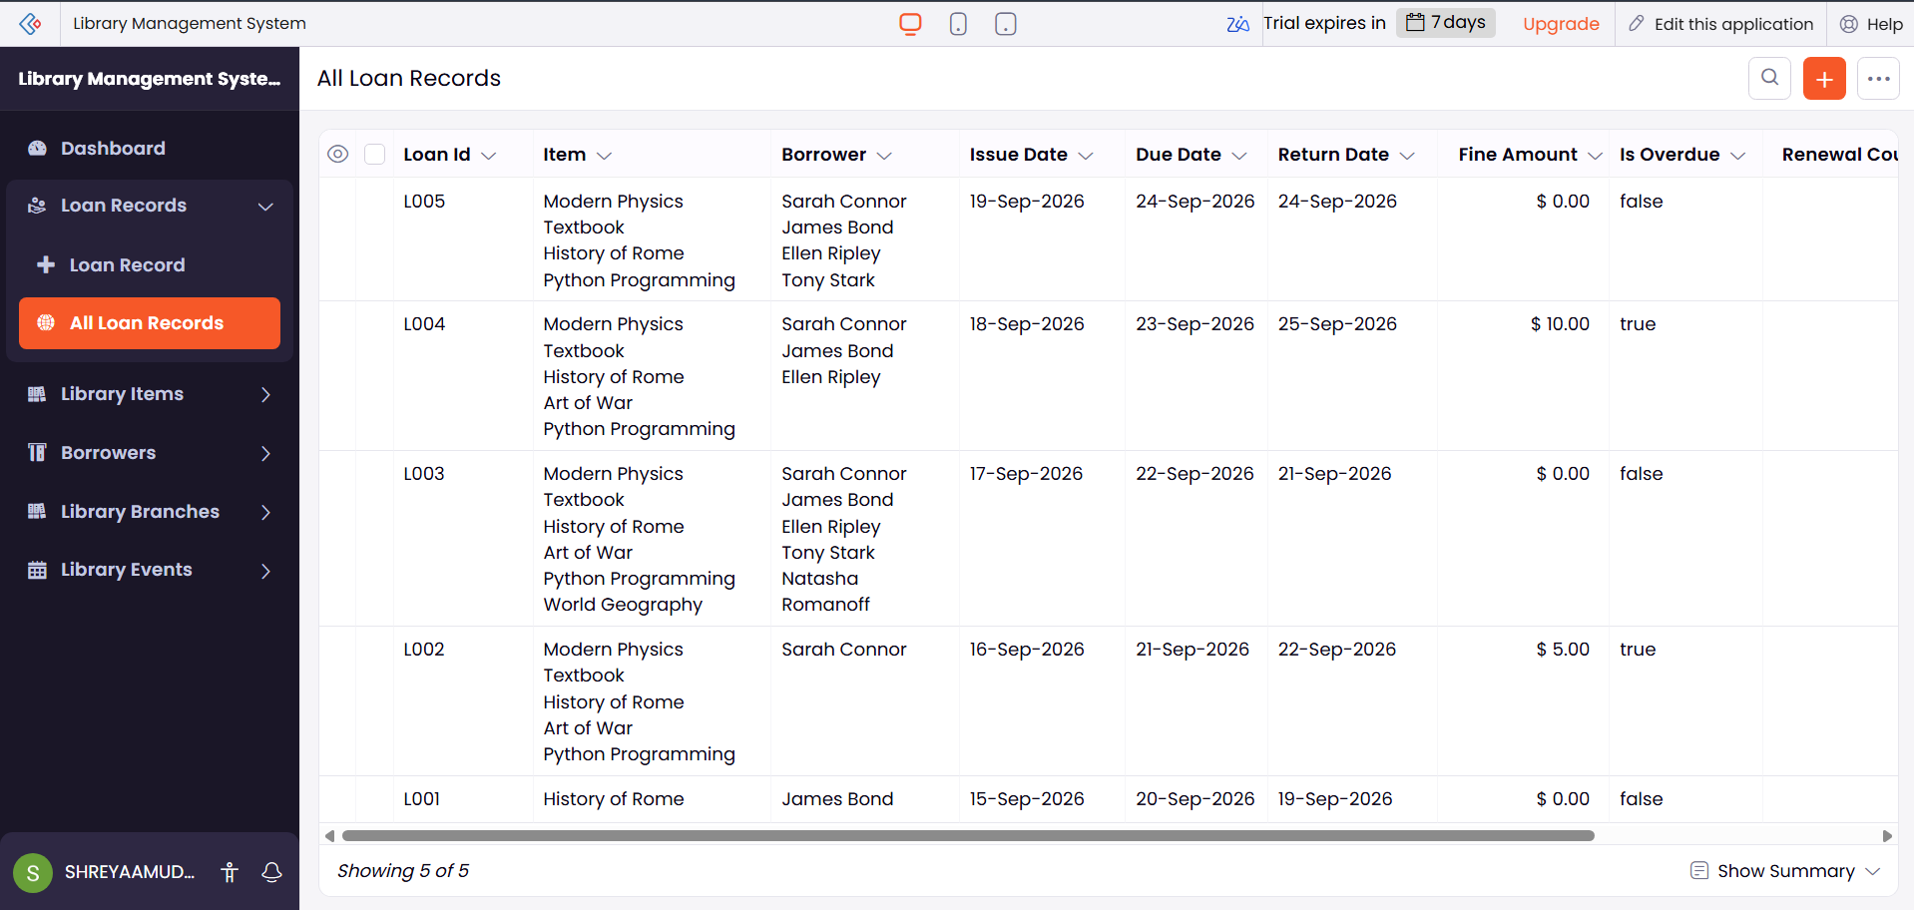
Spread Sheet

Kanban:
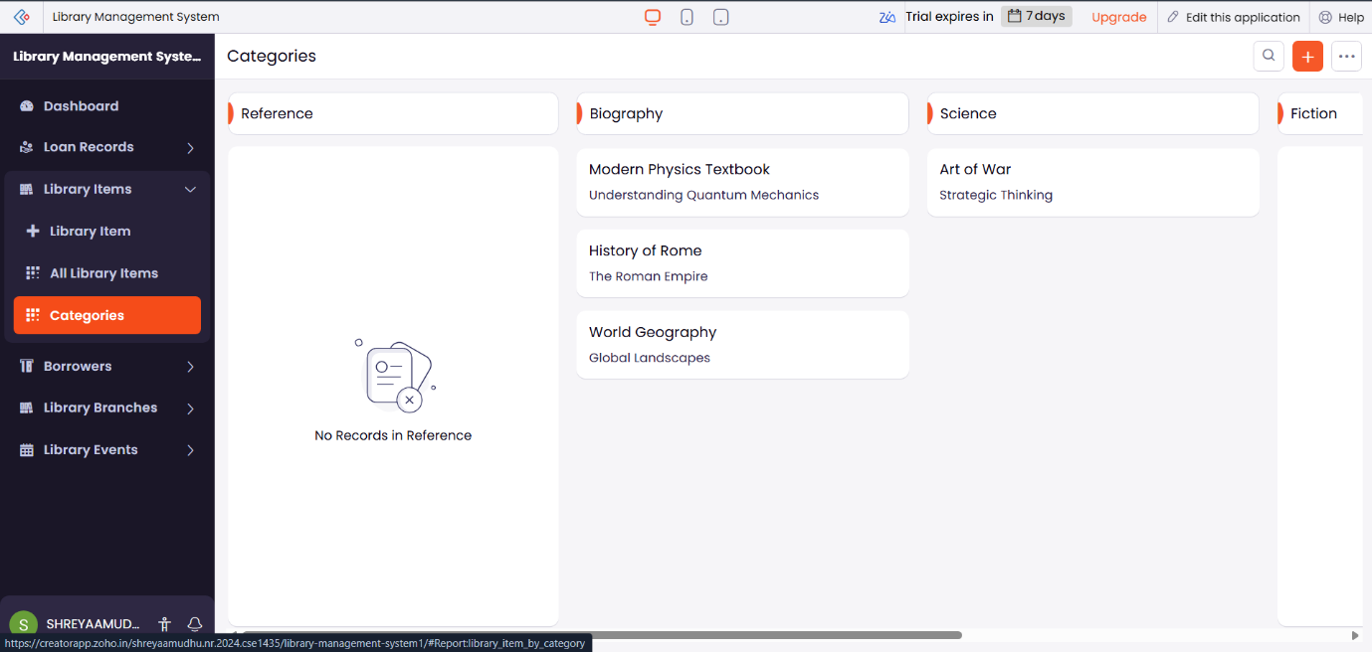

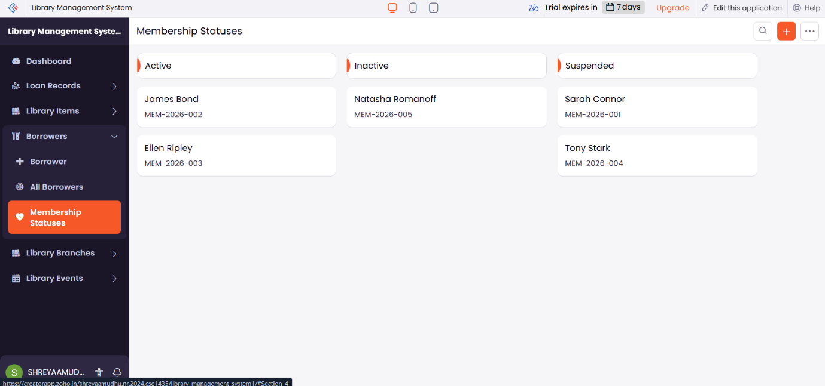

Map:
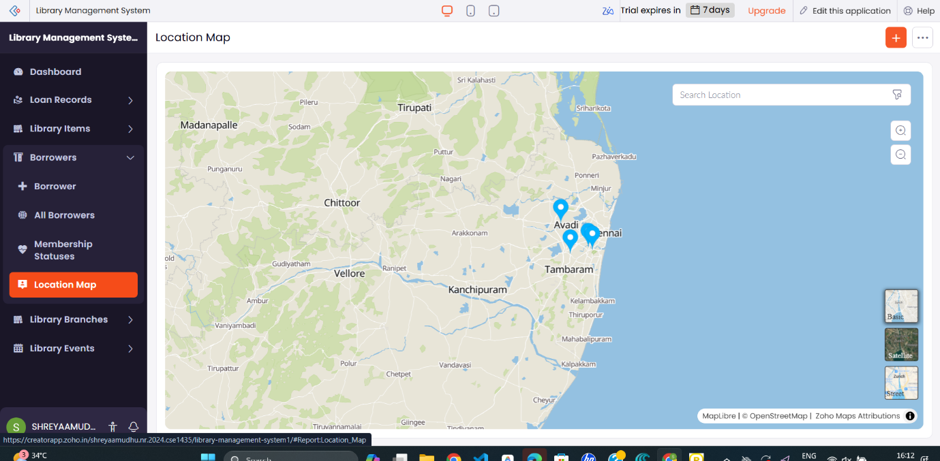

Calender:

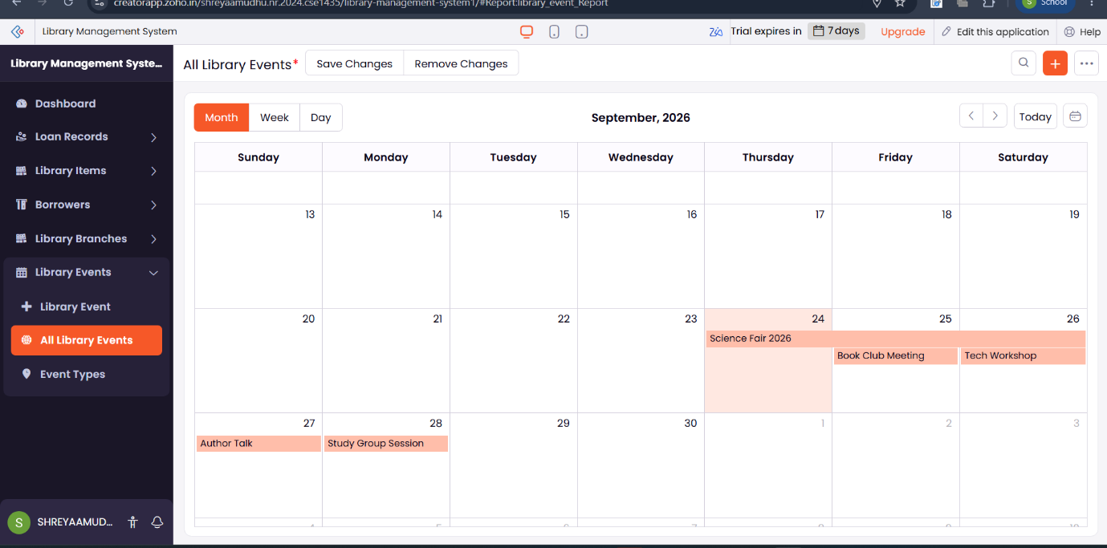
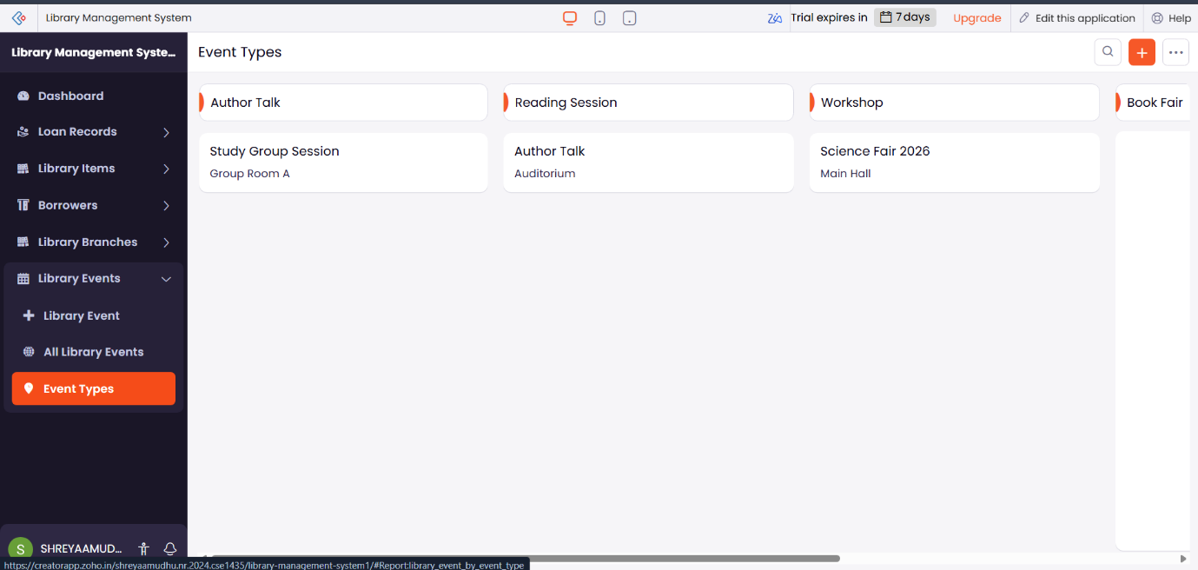

Result
Thus, four basic reports—Loan Record, Library Items, Borrower, and Library Events—were successfully created in Zoho Creator without using Zia. The reports display the existing Library Management System data in a simple and organized tabular format.

